Name: Kasak Patel
Section-Batch: B-B1
Roll No.: 05
ML Practical 6
Date of Performance: 24/09/26

AIM
To implement an Artificial Neural Network (ANN) for multiclass classification using the Seeds Dataset.
OBJECTIVES
- To load and inspect the Seeds Dataset using Pandas.
- To check dataset shape, columns, information, missing values and duplicate records.
- To analyse class distribution and perform exploratory data analysis using histograms and boxplots.
- To study feature relationships using a correlation matrix, scatter plot and pair plot.
- To separate input features and the target class.
- To encode the original classes 1, 2 and 3 as 0, 1 and 2 for ANN training.
- To divide the data into training and testing sets using stratified sampling.
- To standardize the input features using StandardScaler.
- To build a Sequential ANN using Dense layers and ReLU/Softmax activations.
- To train the ANN using Adam optimizer and sparse categorical cross-entropy loss.
- To use EarlyStopping based on validation loss and restore the best weights.
- To evaluate the trained ANN using accuracy, precision, recall, F1-score and a classification report.
DATASET USED
seeds.csv – Seeds Dataset
The dataset contains 210 records and 8 columns. It contains seven numerical input features related to seed measurements and one target column, “Class (1, 2, 3)”, representing three classes.
Software/Tools Used:
- Python 3.x
- Jupyter Notebook / Anaconda
- Pandas
- NumPy
- Matplotlib
- Seaborn
- TensorFlow / Keras
- Scikit-learn

THEORY
Artificial Neural Network (ANN)
An Artificial Neural Network is a supervised machine learning model composed of interconnected layers of neurons. In this practical, a feed-forward Sequential ANN is used to classify observations into three seed classes.
Input and Output
The model receives seven standardized numerical features as input. The final Dense layer contains three neurons with softmax activation, producing a probability for each of the three classes.
Dense Layers and Activation Functions
The ANN in the notebook uses two hidden Dense layers with 16 and 8 neurons respectively. Both hidden layers use ReLU activation. The output layer uses three neurons with Softmax activation for multiclass classification.
Feature Scaling
StandardScaler is applied to the training features and the same fitted scaler is used to transform the test features. Scaling places the numerical features on a comparable scale before ANN training.
Class Encoding
The dataset stores classes as 1, 2 and 3. The notebook subtracts 1 from the target so that the ANN receives encoded classes 0, 1 and 2. Predictions are converted back to the original class labels by adding 1.
Loss and Optimizer
The model is compiled with Adam optimizer using a learning rate of 0.001 and sparse_categorical_crossentropy as the loss function. Accuracy is used as the training metric.
Early Stopping
EarlyStopping monitors validation loss with patience=10 and restore_best_weights=True. This allows training to stop when validation performance no longer improves and restores the best model weights.

MATERIALS / SOFTWARE REQUIRED
- Python 3.x
- Jupyter Notebook / Anaconda
- Pandas and NumPy
- Matplotlib and Seaborn
- TensorFlow / Keras
- Scikit-learn
- seeds.csv dataset

PROCEDURE
- Import NumPy, Pandas, Matplotlib, Seaborn, Scikit-learn and TensorFlow/Keras libraries.
- Load seeds.csv using Pandas.
- Display the first and last records and inspect shape, columns and dataset information.
- Check for missing values and duplicate records.
- Display the class distribution and visualize it using a pie chart.
- Perform univariate analysis using histograms and boxplots.
- Generate a correlation matrix, Area-versus-Perimeter scatter plot and pair plot.
- Separate the seven input features X and target y.
- Encode target classes 1, 2, 3 as 0, 1, 2.
- Split the dataset into training and testing sets using an 80:20 stratified split with random_state=42.
- Standardize the input features using StandardScaler.
- Create a Sequential ANN with Dense layers of 16, 8 and 3 neurons.
- Compile the model using Adam optimizer, learning rate 0.001, sparse categorical cross-entropy and accuracy.
- Configure EarlyStopping with validation-loss monitoring and patience=10.
- Train the ANN for up to 100 epochs with batch_size=16 and validation_split=0.20.
- Plot training/validation accuracy and loss.
- Evaluate the model on the test set.
- Generate class probabilities, predicted classes and a comparison of actual and predicted classes.
- Calculate accuracy, weighted precision, weighted recall and weighted F1-score.
- Generate the classification report.

OUTPUT 1 – DATASET INSPECTION
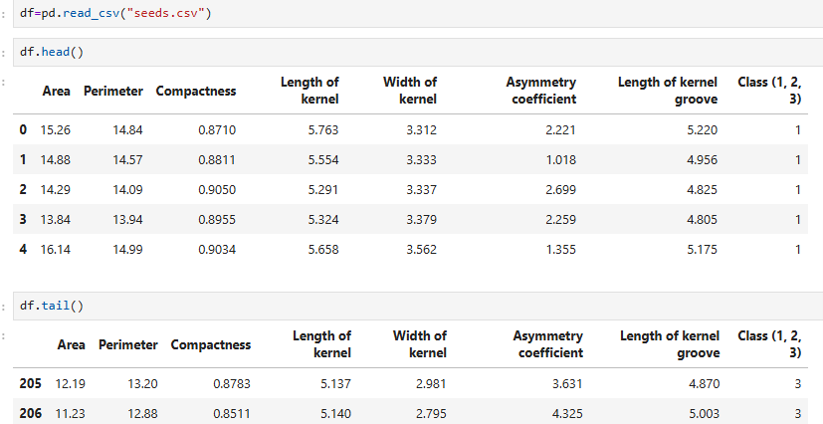
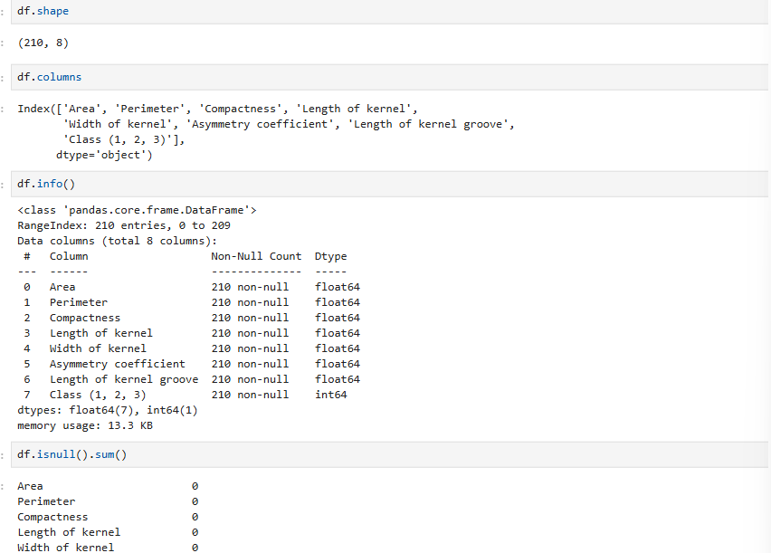
The Seeds Dataset is successfully loaded using Pandas. The notebook output shows 210 observations and 8 columns. All seven input features are numerical, while the target column contains the three class labels. The missing-value check returns zero for every column and the duplicate check returns zero.
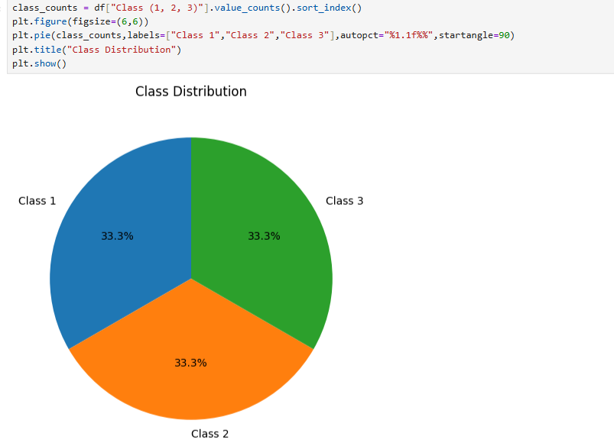
OUTPUT 2 – UNIVARIATE ANALYSIS
Histograms are used to inspect the distributions of the seven numerical input features. The notebook also generates boxplots to visualize the spread and possible extreme observations.
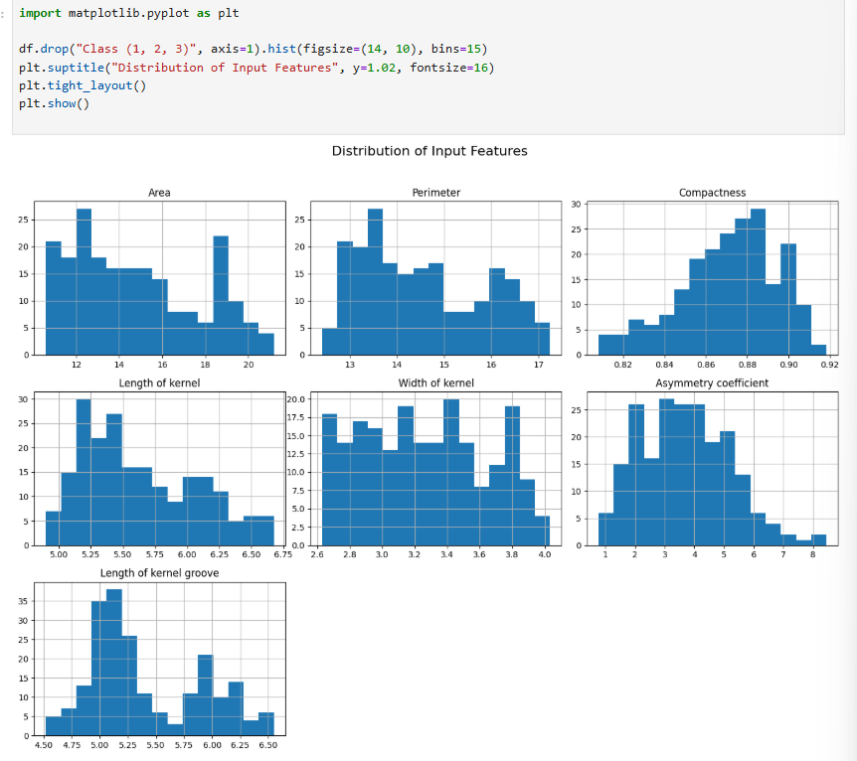
Description:
The histogram grid shows the distribution of each input feature. The feature scales and distributions differ, which supports the use of standardization before ANN training.
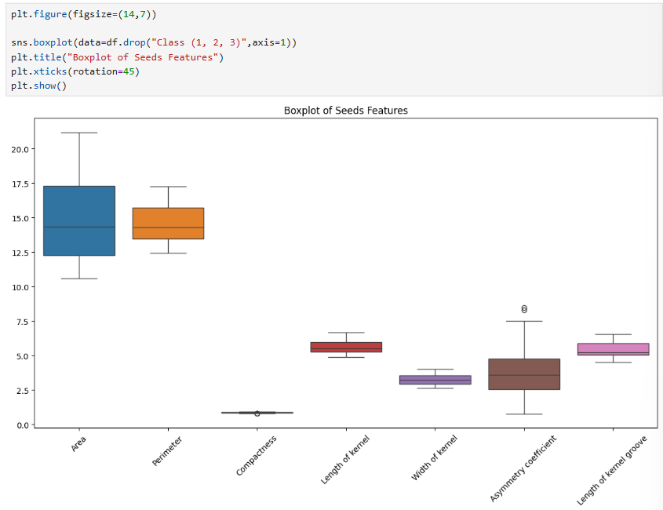
The combined boxplot provides a compact comparison of feature ranges and highlights the presence of observations away from the central range for some features.

OUTPUT 3 – CORRELATION AND BIVARIATE ANALYSIS
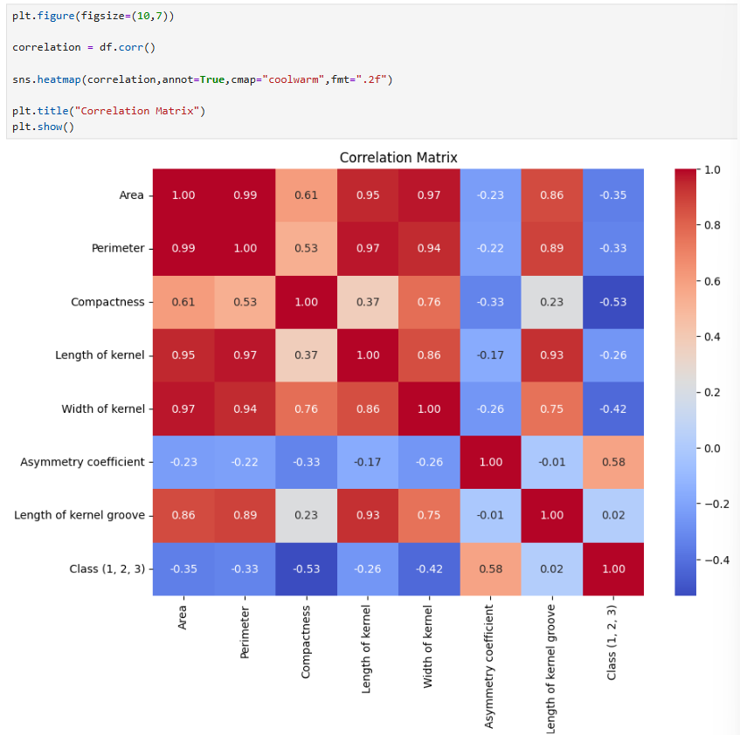
Description:
The correlation matrix displays pairwise linear correlation values among the numerical features and the target class column. It provides an overall view of which variables move together.
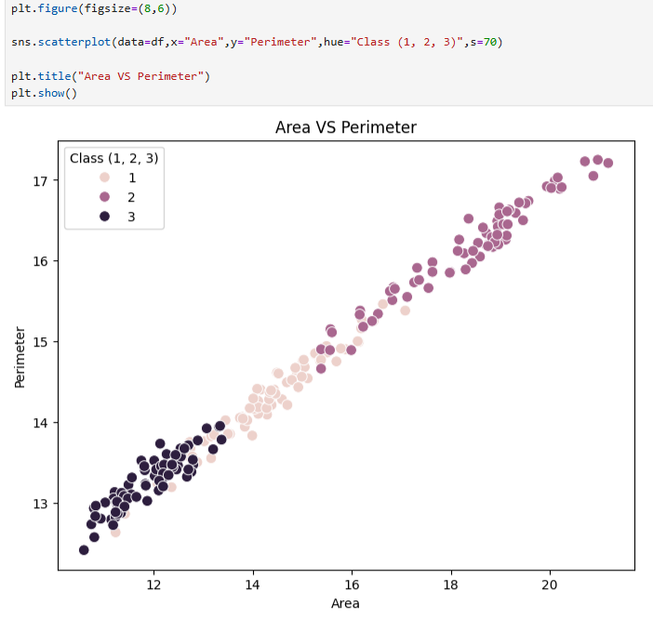
The scatter plot compares Area and Perimeter while using the class label as the hue. This helps visually inspect how the three seed classes are distributed with respect to these two measurements.

OUTPUT 4 – MULTIVARIATE ANALYSIS / PAIR PLOT
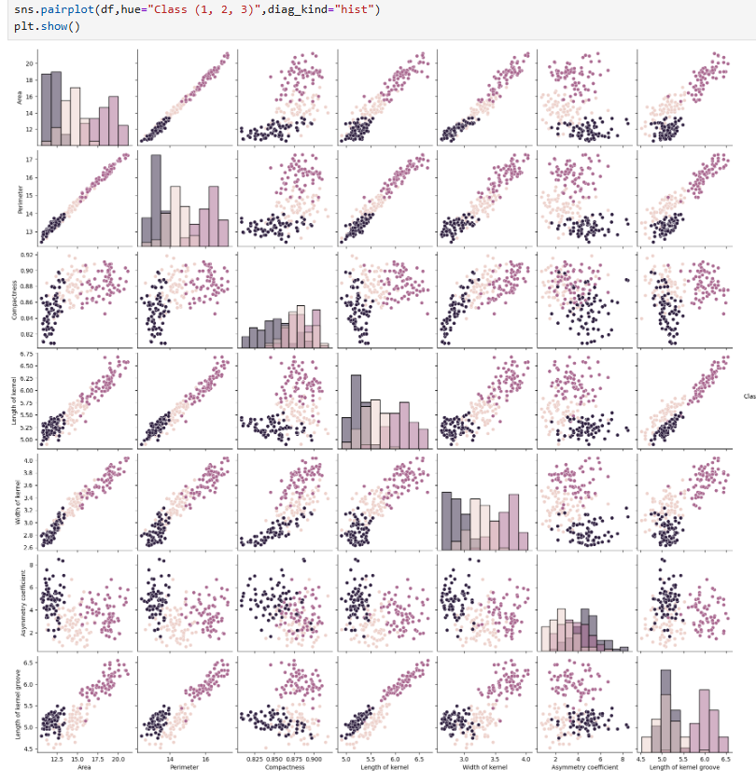
Description:
The pair plot visualizes pairwise relationships among the dataset features while the hue represents Class (1, 2, 3). Histograms on the diagonal show individual feature distributions and the off-diagonal plots show relationships between pairs of features.

DATA PREPARATION
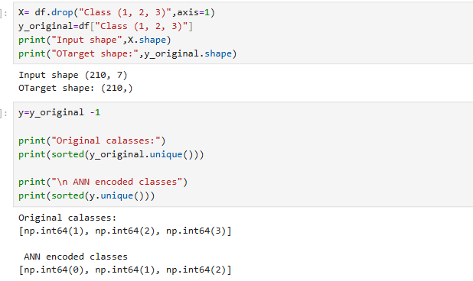
OUTPUT 5 – TRAIN–TEST SPLIT AND STANDARDIZATION
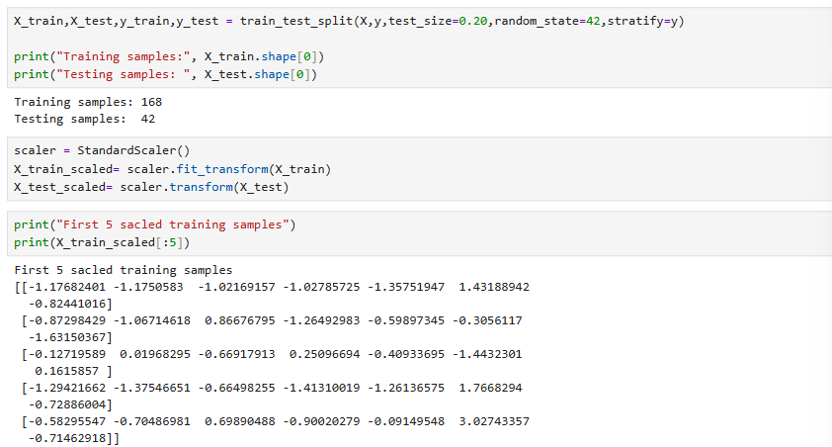
Description:
The 80:20 stratified split produces 168 training samples and 42 testing samples. Stratification preserves the class distribution across the training and testing sets. StandardScaler is fitted on the training data and then applied to both training and testing data.
The notebook prints the first five scaled training samples, showing standardized numerical values around the common scaled range.
ANN MODEL ARCHITECTURE 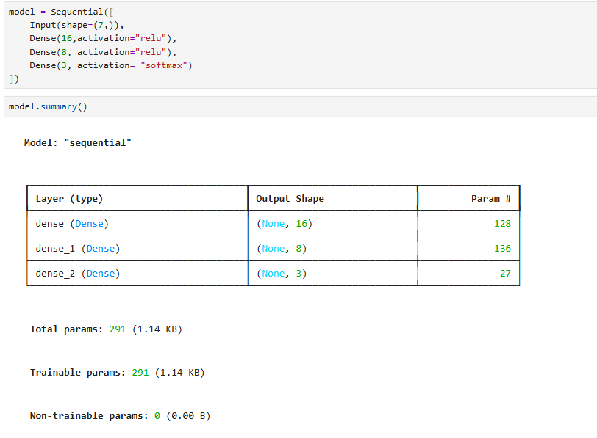
The model contains 291 trainable parameters: 128 in the first Dense layer, 136 in the second Dense layer and 27 in the output layer.
OUTPUT 6 – ANN COMPILATION AND TRAINING
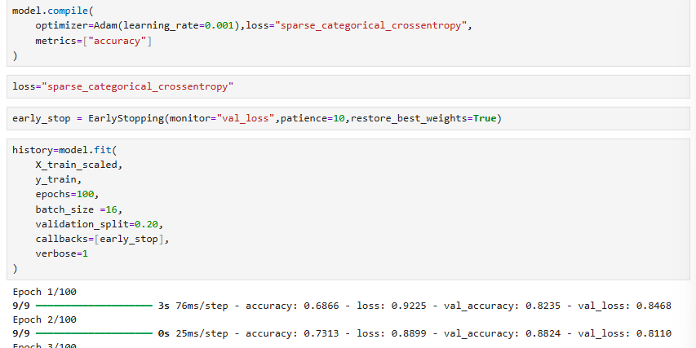
Description:
The ANN is trained for up to 100 epochs with a batch size of 16. A validation split of 20% of the training data is used during training. The notebook records both training and validation accuracy and loss for each epoch.
OUTPUT 7 – TRAINING AND VALIDATION ACCURACY
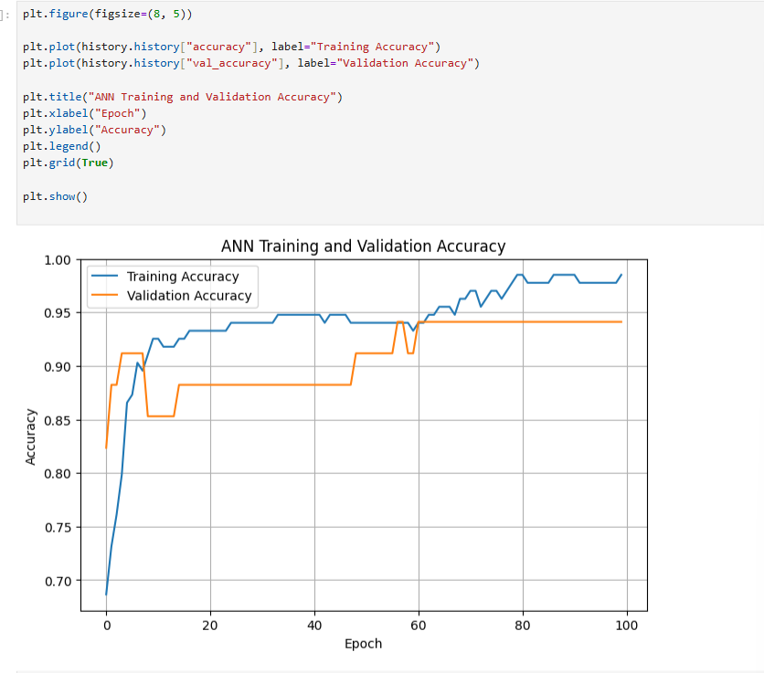
Description:
The accuracy plot shows how training and validation accuracy change over the training epochs. The notebook reaches high validation accuracy in the later epochs, with the validation curve reaching about 0.97 in the recorded training output.

OUTPUT 8 – TRAINING AND VALIDATION LOSS
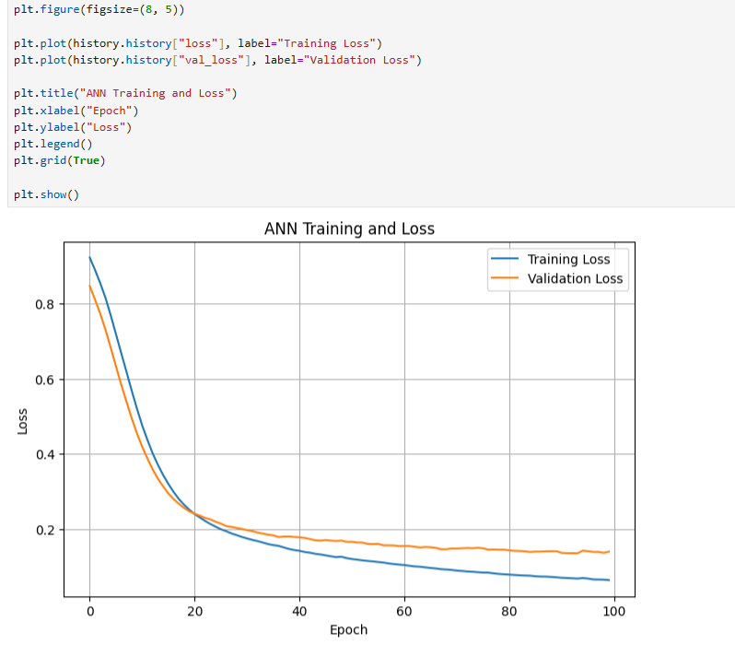

Description:
The loss plot shows the change in training and validation loss during training. The recorded output shows the loss decreasing substantially compared with the first epochs.

OUTPUT 9 – TEST EVALUATION AND PREDICTIONS
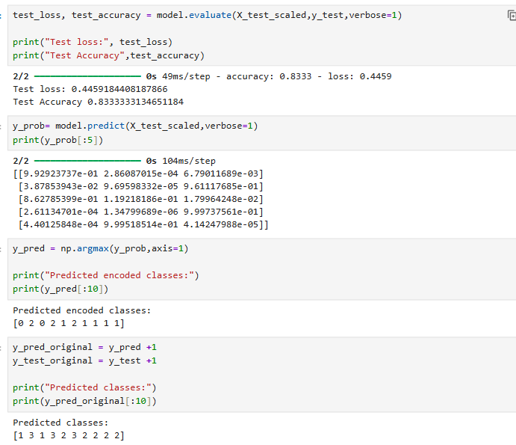
Description:
The trained ANN is evaluated on 42 unseen test samples. The notebook reports a test loss of 0.4306561351 and a test accuracy of 0.8571428657, approximately 85.71%. The model also produces class probabilities using the Softmax output layer.

OUTPUT 10 – PERFORMANCE METRICS
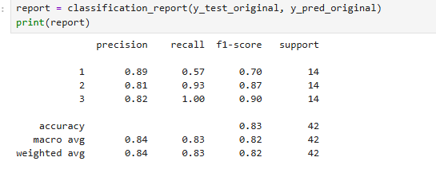
Description:
The classification report gives class-wise precision, recall and F1-score. Class 1 has precision 0.90, recall 0.64 and F1-score 0.75. Class 2 has precision 0.81, recall 0.93 and F1-score 0.87. Class 3 has precision 0.88, recall 1.00 and F1-score 0.93. The overall test accuracy is approximately 0.86.

VIVA QUESTIONS
Q1. What is an Artificial Neural Network (ANN)?
Answer:
An Artificial Neural Network is a machine learning model made of interconnected layers of neurons. It learns patterns from input data and can be used for tasks such as classification.
Q2. Why is StandardScaler used?
Answer:
StandardScaler is used to standardize numerical features so that they have a comparable scale. This helps the neural network train more effectively.
Q3. Why is ReLU activation function used?
Answer:
ReLU is used in the hidden layers to introduce non-linearity. It helps the neural network learn complex relationships between the input features.
Q4. Why is Softmax used in the output layer?
Answer:
Softmax is used in the output layer for multiclass classification. It converts the output values into probabilities for the three classes.
Q5. What is the purpose of EarlyStopping?
Answer:
EarlyStopping monitors the validation loss during training. It stops training when the model stops improving and restores the best weights.

